European Union Rule of Law Mission in Kosovo - www.eulex-kosovo.eu

Towards EU Border Management Practices
By Alexandra George, EULEX Customs Spokesperson
17 June 2009
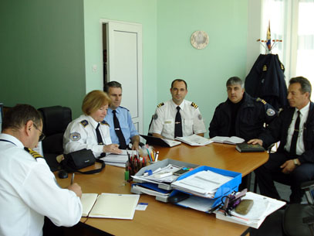
KC and KBP officers attend IBM workshop at Gate 5

“The chart shows the 13 places in a car where smugglers can conceal weapons, drugs, cigarettes,” says Samir Krasniqi, from the Kosovo Customs (KC).
“If our joint Kosovo Customs/Kosovo Border Police (KBP) teams find drugs at the sixth location, inside the doors for example,” Samir continues, “we will call in specially-trained dogs from the Border Police’s Canine Unit. Such joint border control is known as one stop-one search.”
He was presenting new procedures at a joint KC/KBP workshop at Gate 5 (Serbian Administrative Boundary Line) for one stop/one search. These include first line inspection, profiling and data sharing - a concept called Integrated Border Management (IBM).
“Now Kosovo Customs and the Kosovo Border Police have separate booths at the borders, often some distance apart. Under the new one stop/one search system both services will control passenger and car traffic entering and leaving Kosovo from one booth,” says Krasniqi .
One stop/one search is the basis of open borders to allow free trade and free movement of peoples within the EU, a central concept of Integrated Border Management. It is also a key criterion for meeting EU standards on borders/customs which is why EULEX Customs has been promoting this concept.
In recent weeks Krasniqi and Drita Ymeri from the Kosovo Border Police, have visited all of Kosovo’s 12 border/boundary crossing points (BCPs) to present the new procedures.

New National Assembly Law supports open borders
Their programme coincided with the National Assembly’s passage of the Integrated Border Management National Strategy 2009-2012 and Action Plan (2009-2012).
This means Kosovo Customs and the Kosovo Border Police will have common
databases and share their facilities at Kosovo’s 12 border crossing points to make border control faster and more effective.
But problems still exist. There is a lack of infrastructure such as booths at most borders and boundaries and a lack of equipment such as drug testing kits or special scanners to search cars. But all are agreed that, once operational, IBM will help curb smuggling.
Integrated Border Management is to be introduced at all 12 border/boundary crossing points by 2012. “To implement this concept we need the commitment from IBM’s three main actors – Kosovo Border Police, Kosovo Customs and the Kosovo Veterinary and Food Agency,” says Jarmo Kemppinen, EULEX Customs Border/Risk Management Advisor.
_____

